|  |
| --- |
|  |

|  |
| --- |
|  |
| Radar Documentation |
|  |

**SCOPE**

Radar is used for historical reporting purposes. Its modules include *ECHI (External Call History Working), CMS (Call Management System)* and *CDR (Call Detail Recording)*

The purpose of this document is to describe the following modules and their working:

1. *ECHI (External Call History Working):* ECHI records call details of each and every call in terms of customer to agent and vice versa. The document describes the format of the Call History data files and how to transfer these files.
2. *CMS (Call Management System):* This is an application for businesses and organizations that use Avaya communication servers to process large volumes of telephone calls. CMS supports solutions for routing and agent selection, reporting, interfaces to other systems, workforce management, desktop applications, and quality monitoring.
3. *CDR (Call Detail Recording) :*

**DATA SOURCE**

1. ECHI uses flat files,
2. CMS uses Informix database,
3. MySQL acts as ECHI and CMS repository.

**SOFTWARE REQUIREMEMTS**

1. PHP
2. MySQL
3. JAVA
4. Scripting Languages(HTML, Jquery, AJAX, Javascript)

**FLOW OF APPLICATION**

1. *ECHI* :

It is a java-based application (JAR) deployed in 10.100.8.141. Initially, files from CM are archived on 10.100.7.9 server. A batch file is executed every two minutes, and moves the current CHR file from 10.100.7.9 to 10.100.8.141.

ECHI is scheduled to run at every half hour interval, which imports ECHI flat files (CHR*.*) from 10.100.7.9 server.

After importing processed CHR file, it is moved to another folder with current data. Log file is generated for each step of execution of importing files.

In case of failure, scheduled job is executed or rerun for importing data. The import module is built using Java and MySQL. The JAR is scheduled in a task scheduler in 10.100.8.141 server.

Echi Query Builder is used to generate report from imported data. In this module, users have option to choose required information like database type, time zone, date-time range and echi fields. Echi query builder build query based on given limitation or condition and fetch data from database and generate report in CSV format. User can save the query for future use. The saved query can be either private or shared. That means the query can be shared within limited users.

Abandon module generates report on abandon calls. This module requires Date-Time, Time-Zone, Abandon Type, Abandon Call Duration, Days Subtracted and Days Added as input. Users have to choose VDN and Split. Based on input data, VDN and Split this module build query and fetch data from database and generate report in CSV format. User has option to save query which can be run or update in future.

1. *CMS* :

The raw source data is taken from Informix data source. A JDBC connection is established between Java application and Informix database for raw data. A JAR is developed in Java which is schedules to run every half hour.

In case of failure, the JAR needs to be run from the scheduled task which will take the last interval from the MySQL database and fetch data based on the last record of MYSQL from Informix.

Log for every insertion has been maintained in a log file (cms*log.log).

CMS module provides solutions on reporting, quality monitoring and workforce management. CMS module reports either custom or standard. Custom reports are generated based on two given dates and Standard report are divided into four categories, 1) Daily 2) Interval 3) Weekly 4) Monthly. Kind of reports that can be generated are given below,

|  |  |
| --- | --- |
| Standard: | Custom: |
| 1. VDN Report  2. VDN Split Skills Report  3. Agent Report  5. Agent Split Skill Report  6. Agent Group Report  7. Agent Group Split Skill Report  8. Split-Skill Report  9. Split-Skill-Summary Reports  10. Trunk Report  11. Trunk Group Report  12. Trunk Summary Report | 1. VDN Interval Report  2. VDN Daily Report  3. Agent Interval Report  4. Agent Daily Report  5. Split Interval Report  6. HNS Out Bound Split Report  7. HNS Out Bound Agent Report  8. Telus Client Report |

To generate report we need report specific data as input e.g, for VDN Report it require VDN, Split, Skill, Date and Time zone. Reports are generated based on these inputs.

**PROCESS FLOW DIAGRAMS**

**ECHI:**

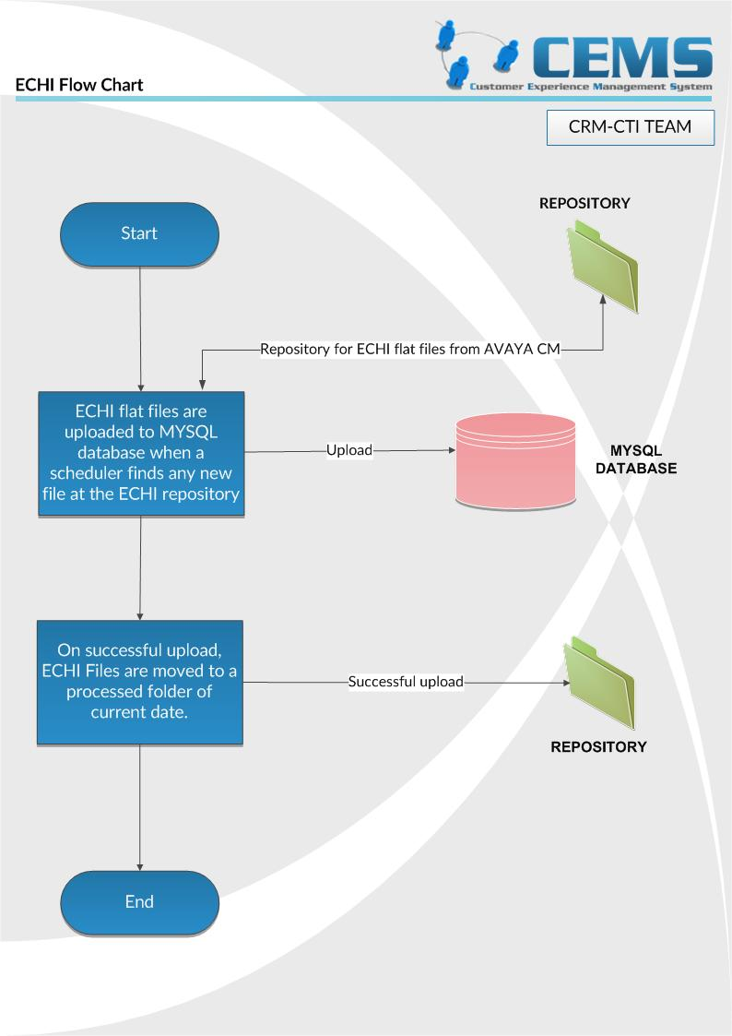

**CMS:**

